BEST

Burnsville, Eagan, Savage Tribune

3.1.23

William Sommers, PhD

Announcements

**2023 SPRING CONFERENCES**

**repeat**

Parent Teacher Conferences are March 8th from 4:30pm-8:00pm, March 9th from 12:00pm-8:00pm, and March 10th from 8:00-11:45. Please click on the link below to sign up:<http://myconferencetime.com/bhs>

Parent Engagement Night

Parent Engagement Night for**Thursday 3/9 from 6-7:30.** We will have a dedicated space for:  Somali Community, Latino Community, African American Community, and SPED with cultural liaison, deans, counselors, and sped staff for each respective community.  Information will be shared about: Attendance, Schoology, Parent Vue, graduation requirements, and credit recovery.   If you have students whose families would benefit from this event please personally invite them.  We have sent specific invitations to 9-12 grade students with 4 or more NC's.  This is available for anyone who is not already set up in parent vue or don't understand grad requirements or have children who will need credit recovery could benefit.

Here is a flyer for you to share or post:  [Parent Engagement Night Flyer](https://mail.google.com/mail/u/0?ui=2&ik=39c9d98048&attid=0.1&permmsgid=msg-f:1759291553557510658&th=186a4258ca23fa02&view=att&disp=inline&realattid=e847ef2a30e2750d_0.1).

**2023 SENIORS**

**repeat**

**Class rank and course history can be found under course history in Studentvue**

**Need a Transcript sent???**

To order a transcript to be sent to a college please do the following.

If you did your application with the Common app, please follow these simple instructions to link your Common App with Xello:

<https://youtu.be/04NM98f0pPc>

As the final semester begins some students might need specific credits to graduate or complete a prerequisite before moving to the next level in a sequence. An example, completing Geometry, Science, etc. The credit recovery program is designed to help students be on track for graduation and fulfill the requirements of course.

*There is a day program that can fit into a study hall period as well as an afterschool component. Our goal at BHS is to create opportunities for students so they graduate on time. More specific information is below.*

Blazing Commitment Award

Landen Parkin and Molly McCool were recognized the Javier and Neil, our SROs for their amazing work with 9th grade students and special services students. Molly works in the STEP program and Landen in addition to teaching English is the Asian Student Association staff advisor.

Community of Excellence Award

On Wednesday, March 1st at the BHS staff meeting two of our colleagues received the Community of Excellence Award.

Marcia Sexton

Landen Parkin

Congratulations for both for outstanding work for kids, colleagues, and community. BHS is better because of your work.

National Honor Society Scholarships

BHS National Honor Society chapter has announced that Cade Bunnell, Isabella Ly, and Elizabeth Genis, have been selected as a National Semifinalist for the National Honor Society Scholarship! As a National Semifinalist, they will receive a scholarship award of $3,200.  Congratulations.

Principal’s Perspective

Doc goes to school

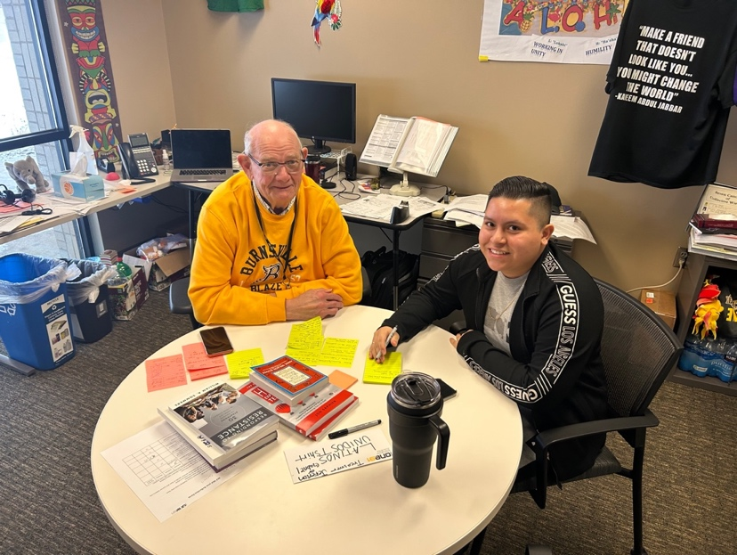

“Vladimir es mi maestro professor.” School is about learning. One thing I have discovered in my career, learning can happen at any time, any place, and from anyone willing to teach you. What is required for learning are three things:

* Courage to say, “I need help” or “I am not as good as I want to be” or “I would like to learn something new.”
* Humility to accept you may not know everything and are open to learning and being taught.
* Discipline to follow through. Take some positive action that will help yourself get better or learn.

Let introduce you to my teacher. Gerson Villata Umana, (he goes by Vladimir) a junior at BHS, is teaching me Spanish during his study hall. Gerson is busy with the student Latino group and other commitments. I am grateful that he can give me lessons a couple time a week.

I get about two small pages of notes, practice saying the comments, and try to remember what I am learning. I admit I am not very fluid and I am picking up phrases and vocabulary. It really is never too late to learn. It just takes the willingness to consider new ideas, be considerate, and be willing to practice.

*“'When the***student is ready***the***teacher***will***appear***”*

Tao Te Ching

